# **Active Directory**

**Steps To Install Active Directory (AD):**

1. Open Server Manager.

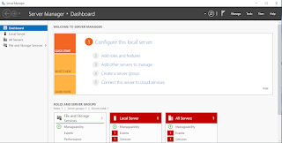

1. Go to Manages > Add Roles and Features.

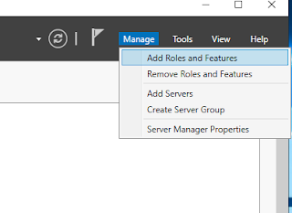

1. Go to Server Roles.

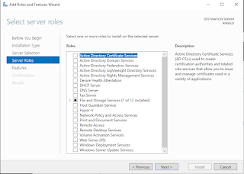

1. Choose Active Directory Domain Services. Click Add Features without changing anything set.

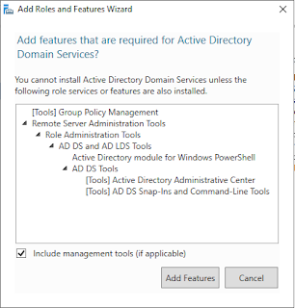

1. Click Next until Confirmation. Tick Restart the destination server automatically if required and install.

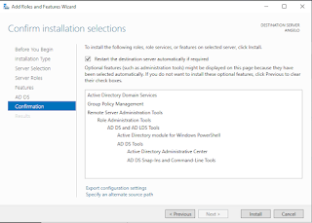

1. Wait until it finishes. After the installation is finished, close it.

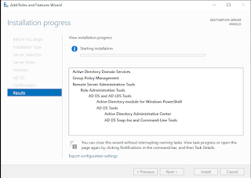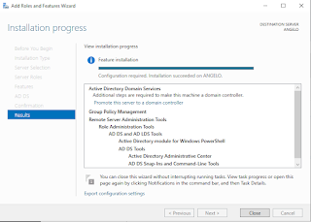

1. Click the alert symbol. After that, click Promote this server to a domain controller.

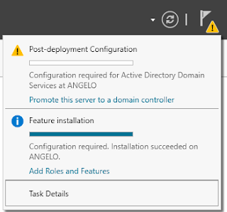

1. At Deployment Configuration, choose Add a new forest. Put any name you preferred. ANGELO.NET is just an example. Click next.

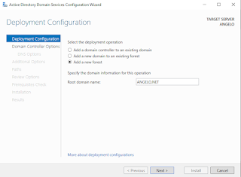

1. Enter password you preferred. Click next.

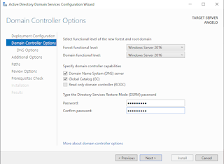

1. Click next until Additional Options. If the name is already in use, you can change it or just leave the suggestion one. Click next.

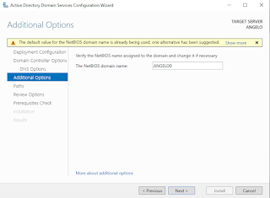

1. Click next until Prerequisites Check. After that, click install.

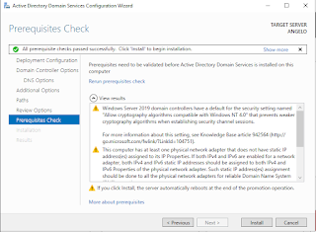

1. Wait until the installation is complete. After complete, your server will automatically restart by itself.

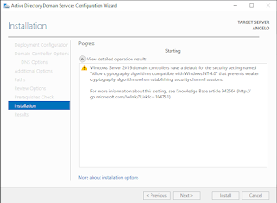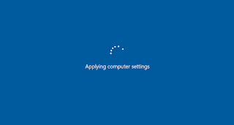

1. After restart, enter your server by using the password you set previously.

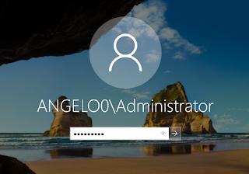

1. Go to computer information, check domain status. If it shows the domain name that you created previously, it means that you have successfully installed and made your server an Active Directory server.

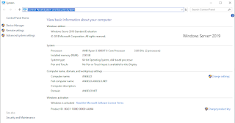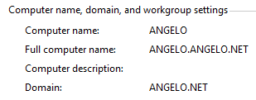

**Check USERDOMAIN Active Directory (AD):**

1. Check USERDOMAIN is very important because it will be used for log in to servers that joins your Active Directory.
2. Open CMD.
3. Type SET USERDOMAIN and press enter.

